Microprocessor write up

Part A

My partner for this segment of the homework assignment was Wasim Khan. We first obtained the output characteristics of the Active High by setting the output of pin 1 to 1 through code composer. We used resistors with values of 10ohm, 100ohm, 1kohm, 10kohm, 50kohm, 100kohm, and 1Mohm. We used a multimeter in the Electric circuits lab to measure both the current and the voltage at the same time by sharing a node between them. Since it was in series, the current was the same throughout the circuit and voltage was measured at V with respect to ground. Then for the active low, we used the same resistor values. We also changed the output for pin 1 to 0, through code composer.

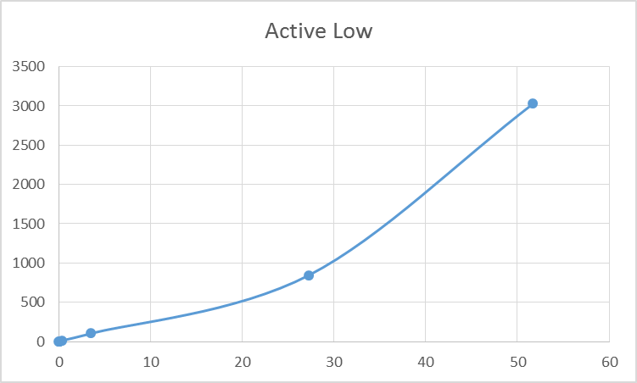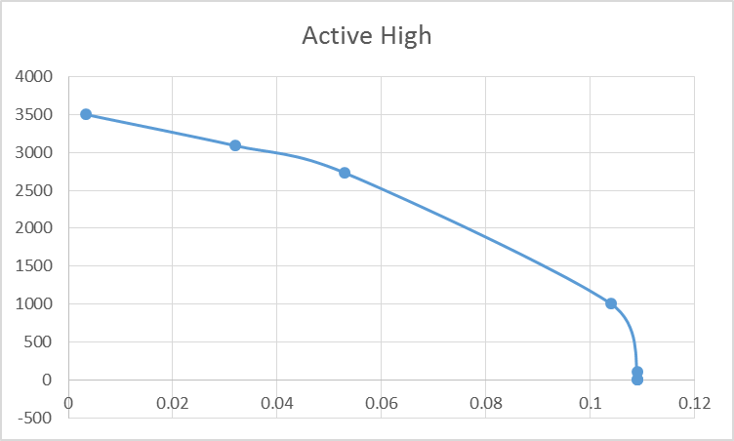

Part B

To measure the frequency of the DCO clock, I used a Pico scope, which was connected to the ground and p1.1. The measured DCO frequency with the default parameters for the G2553 was 1.01MHz. This result is obtained after multiplying the measured frequency of 987.2 Hz by 1024. The highest frequency the DCO will go seems to be 20.131 Mhz. This is obtained by setting RSELx = 15, DCOx = 7, and MODx = 0. I was able to get a frequency of 4.997 Mhz on the G2553 by setting the DCOCTL to the binary number of 0010 1111, which is 0x2F and by setting the BCSCTL1 to the binary number 0100 1100, which is 0x4C in hex. The parameters relating to those numbers are the RSELx = 12, DCO = 1, and MODx = 15. I got these values by first increasing the RSELx parameter until I got to about 5.7 Mhz. Then I decreased the DCOx value and increased the MODx value until it became 5MHz.